**Shoulder and back pain.**

**Initial Assessment**

|  |  |  |
| --- | --- | --- |
| **Presenting Symptom/Chief Complaint** | | |
| Acute neck obstruction syndrome on the right side with shoulder radiation due to cold. | | |
| **Main Signs and Symptoms** | | |
| Stiffness and rigidity of the neck on the right side, aggravated by cold and windy weather. Radiated to the right shoulder. | | |
| **Other Signs and Symptoms** | | |
| Limitation of movement in the neck from side to side. Abduction of the right area due to LI channel involved. | | |
| **TCM Diagnosis and Treatment (identified TCM disease, TCM differentiation of syndromes)** | | |
| Acute neck obstruction syndrome with radiation to the right shoulder due to cold invasion. LI syndrome. | | |
| **Treatment Principles and Strategies** | | |
| Remove wind; eliminate cold, with use of peripheral points by releasing technic, than use of local points tonification. | | |
| **Treatment Plan (Modalities; acupuncture, herbal, dietary, manual therapies), frequency and duration** | | |
| Acupuncture: LI(bilateral) LI 11(bilateral)-eliminate cold. GB39(bilateral)-free link side to side movement.  ST38(right side), ST3(right side), GB 20(bilateral), DU 16-due to wind, GB 21(bilateral)-relaxation of trapezia muscle. | | |
| **Any other Advice Given to Patients** | | |
| Recommended exercises for neck starting from the fourth session. Warm diet. | | |
| **Practitioner:** | **Date:** | **Signature:** |

**Shoulder and back pain.**

**Daily Charting____________________________________Patient Name:_ Boutcharski Danil**

**Date:**

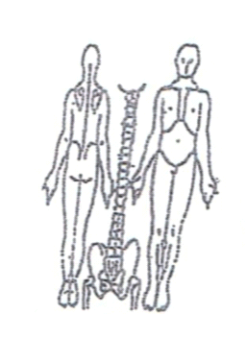**Working Diagnosis:** Acute neck obstruction syndrome with radiation to the right shoulder due to wind cold invasion, LI syndrome.

S: Stiffness and righting of the neck, pain level 3-4. ROM. Side to side movement.

O:

Treatment (P) Acupuncture: LI(bilateral) LI 11(bilateral)-eliminate cold. B39(bilateral)-free link side to side movement.ST38(right side), ST3(right side), GB 20(bilateral), DU 16-due to wind, GB 21(bilateral)-relaxation of trapezia muscle .

(A) Acupuncture 1 hour every third day with warm up needles.

**Date:**

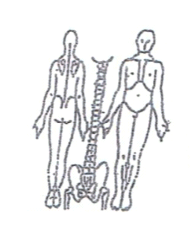**Working Diagnosis:**

S: Symptoms the same. Pain level the same. Neck stiff and rigid. Sleep better.

O:

Treatment (P) Acupuncture according to protocol 1 hour.

(A)

**Date:**

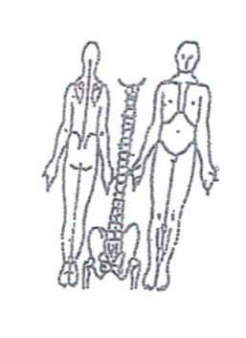**Working Diagnosis:**

S: stiffness and rigidity, ROM, pain level 2-3

O:

Treatment (P) Acupuncture - 1 hour.

(A)

**Date:_**

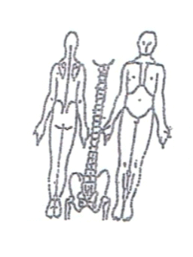**Working Diagnosis:**

S: Normal neck movement. Still have pain 1-2 in the right shoulder. Sleep better.

O:

Treatment (P) Acupuncture + stretching exercises 1 hour.

(A)

**Date:**

**Working Diagnosis:**

S: No pain. N ROM. N sleep. No stiffness. No rigidity.

O:

Treatment (P) Acupuncture 1 hour + stretching exercises.

(A)